Assignment 17.2

Write a secondary sort program to generate the top 2 maximum temperatures corresponding to every year from the temperature dataset.

//driver class

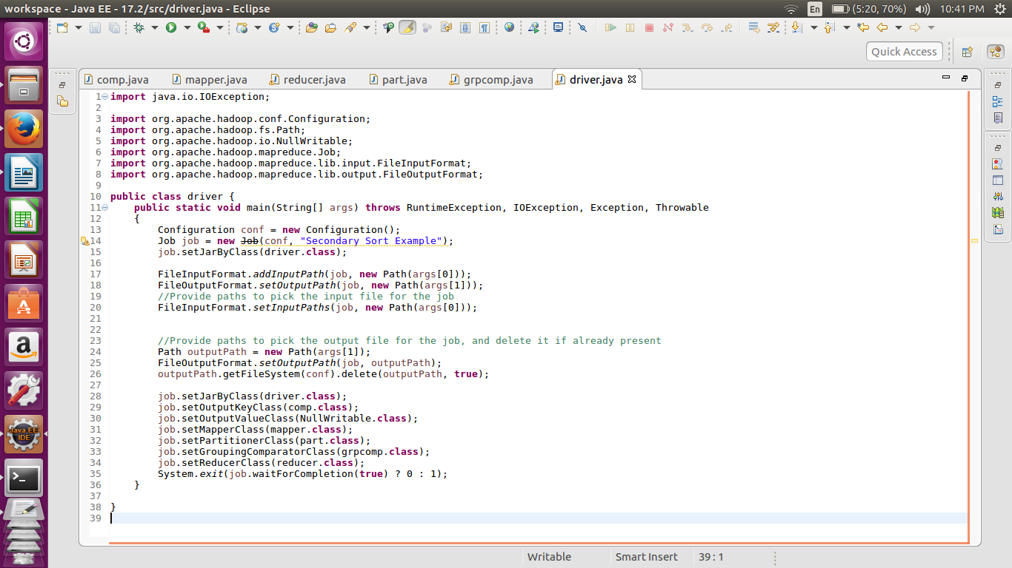

//mapperclass

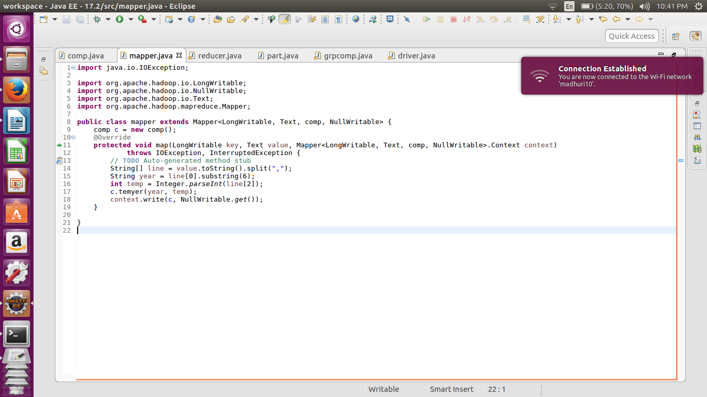

Custom key called as comp is used. An object of the custom key is created and the values of the year and temp are created.

The Mapper passes only the custom key and null writable

//Composite key

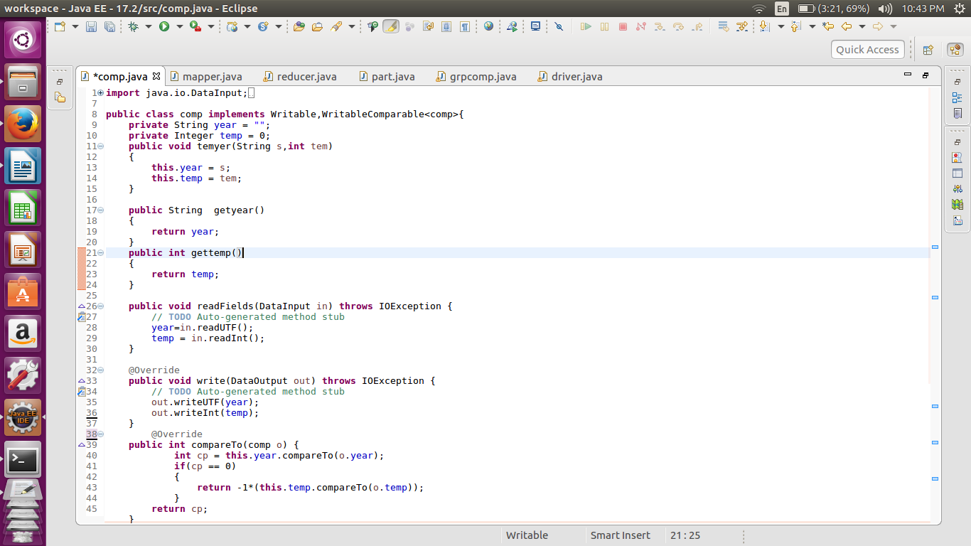

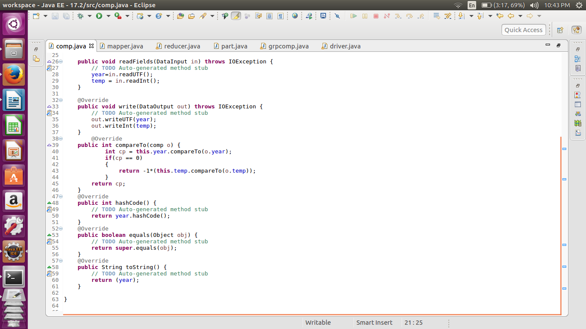

Here in the composite key we are comparing the year first and then the temperature and arranged in the descending order. Hence we will get the highest year first in each of the year

//partitioner

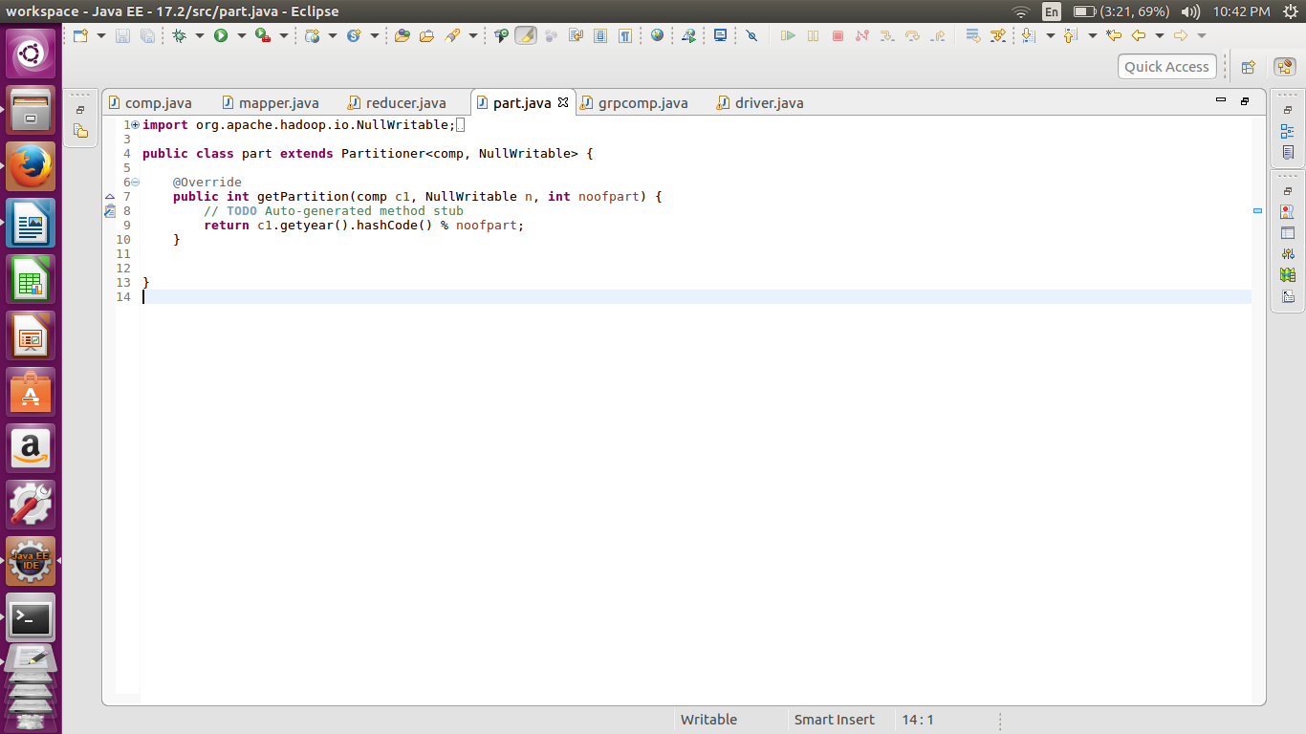

Here we are sending the key values pair to particular reducer on the basis of the year and the not the temp. hence over ridding the pratitioner class.

//group comparator

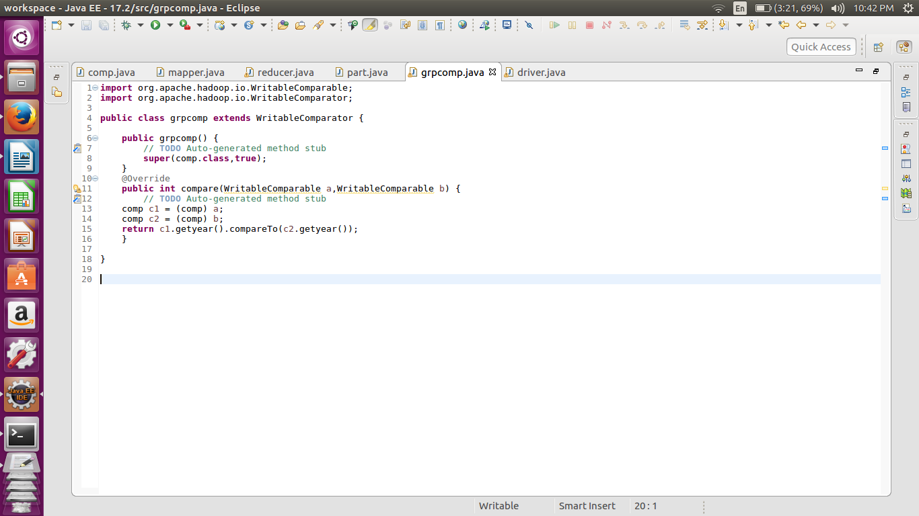

The Group comparator is used to group the values of each year together before going to the reducer. The grouping is also done on the basis of the year and not the composite key.

//reducer

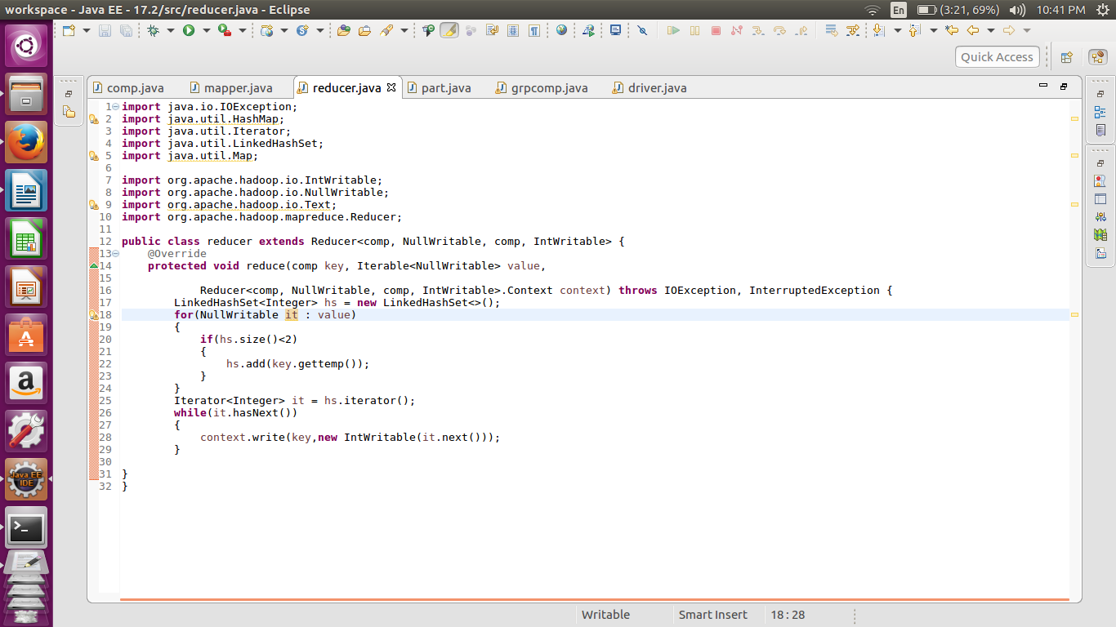

In the reducer first we are storing the values in the linked hash set to preserve the order. Hence the highest temp first and then the second highest. Also the size of the hash set is limited to 2 so that only top two values will be stored.

Then the values are iterated and passed to context.write

//implementation

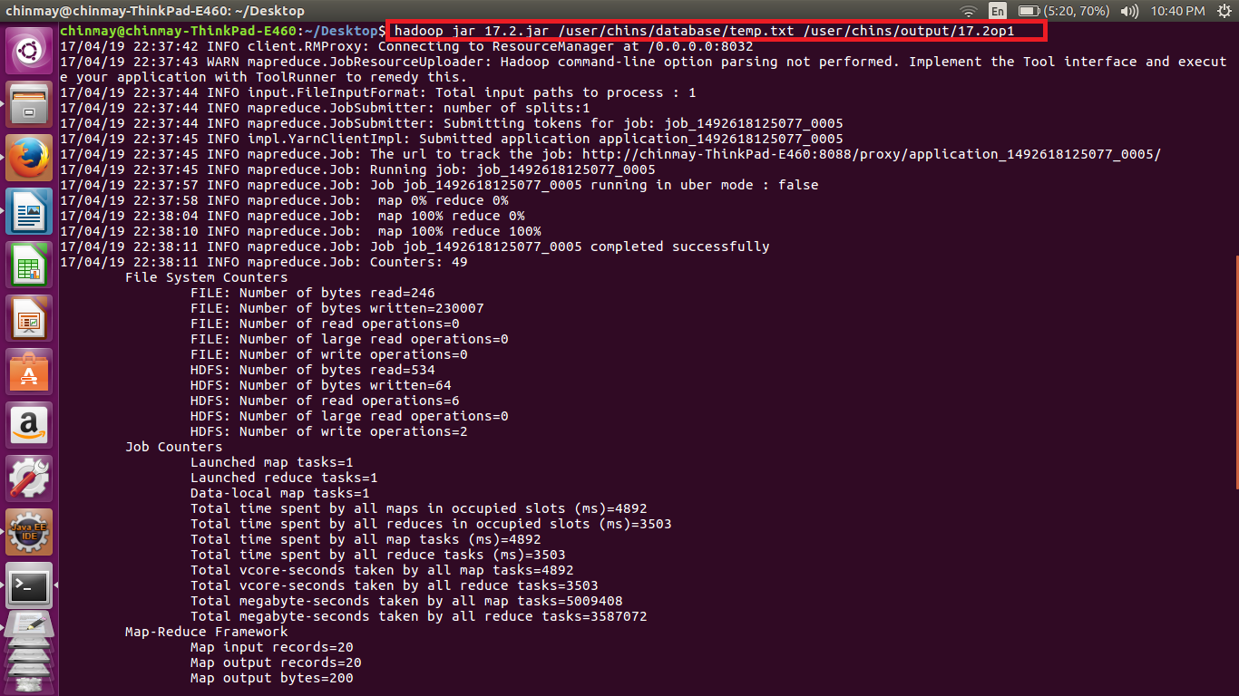

//output

